Result Adjunct

✅ What Is a Result Adjunct?
# Source: AI Source: Provided by: [Data Path: Persons Table -> ID Column: 1, Name_En Column: Motasem Essam] -> From: [Chatgpt (GPT-4-turbo)] on [8/6/2025]
A result adjunct expresses the outcome or consequence of the action in the main clause. It shows what happened as a result of something else.
It answers the question:
- What happened as a result?

🔸 Common Forms of Result Adjuncts:
# Source: AI Source: Provided by: [Data Path: Persons Table -> ID Column: 1, Name_En Column: Motasem Essam] -> From: [Chatgpt (GPT-4-turbo)] on [8/6/2025]
- Conjunctional Clauses: so, so that, such that
- Prepositional Phrases: as a result of, because of that
- Adverbs (Sentence Level): therefore, thus, consequently

🔸 Examples of Result Adjuncts in Sentences:
# Source: AI Source: Provided by: [Data Path: Persons Table -> ID Column: 1, Name_En Column: Motasem Essam] -> From: [Chatgpt (GPT-4-turbo)] on [8/6/2025]
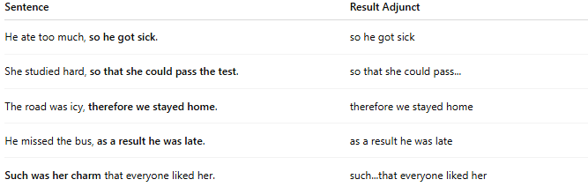
Sentence | Result Adjunct
He ate too much, so he got sick. | so he got sick
She studied hard, so that she could pass the test. | so that she could pass...
The road was icy, therefore we stayed home. | therefore we stayed home
He missed the bus, as a result he was late. | as a result he was late
Such was her charm that everyone liked her. | such...that everyone liked her

🔸 Position in the Sentence:
# Source: AI Source: Provided by: [Data Path: Persons Table -> ID Column: 1, Name_En Column: Motasem Essam] -> From: [Chatgpt (GPT-4-turbo)] on [8/6/2025]
- Medial/Final: He was tired, so he went to bed.
- Initial (adverbial): Therefore, they canceled the meeting.

🔸 Reminder:
# Source: AI Source: Provided by: [Data Path: Persons Table -> ID Column: 1, Name_En Column: Motasem Essam] -> From: [Chatgpt (GPT-4-turbo)] on [8/6/2025]
A result adjunct is not required for sentence structure, but it clarifies cause-and-effect relationships.
🟢 "He got sick."
🟡 "He ate too much, so he got sick." → Adds consequence

